Process Book

CS 6630 Visualization for Data Science

Final Project: Weather and Climate of Utah

Savanna Wolvin, Michael Pletcher

**Overview and Motivation:**

Precipitation is chosen because Utah’s water resources rely heavily on cool-season snowfall at high elevations. Mountain snowpack acts as a natural water tower that stores a large fraction of Utah’s water resources over the warm months. Specifically, about 53% of the total water runoff in the intermountain west originates as snowmelt from higher terrain, replenishing Utah’s reservoirs each spring. Identifying trends in precipitation during the cool season at mountain and valley sites across Utah could allow local water resource managers to act accordingly when planning their water resource distribution plans. Furthermore, extreme precipitation events across regions of complex terrain can produce natural hazards such as flash flooding, landslides, and avalanches, resulting in damage to property, loss of life, and travel disruptions. Thus, we propose identifying trends in precipitation could be useful for water resource managers and emergency personnel across the state.

Additionally, we focus on temperatures to understand whether there are long-term changes in temperature at some sites or across the state. Temperatures directly determine if precipitation falls in a liquid or solid phase, affecting the total snowpack accumulating over the cool-season. In the warm-season, increased temperatures can result in enhanced wildfire activity across the western U.S., although this is not always the case. We aim to identify potential trends in temperature as well as wildfire activity at observing sites across Utah to check for any correlation between them. This information can be used by emergency and wildfire personnel to plan when the most resources should be used during the wildfire season.

**Related Work:**

1. University of Utah’s MesoWest dashboard

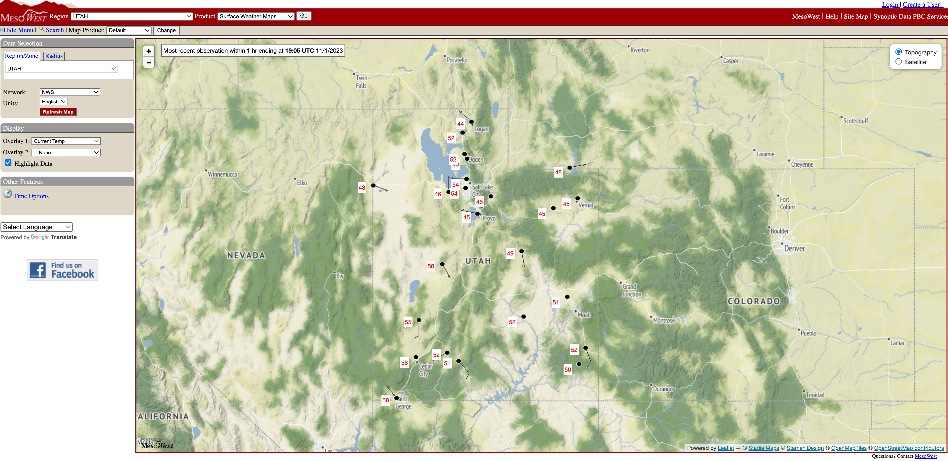

An inspiration for the interactive map is the MesoWest dashboard run by the University of Utah. The dashboard allows users to select any station available in the MesoWest network and provides real-time temperature, wind, humidity, and precipitation data for the selected station when available. We chose to visualize climatology data and not real-time data, however.

1. 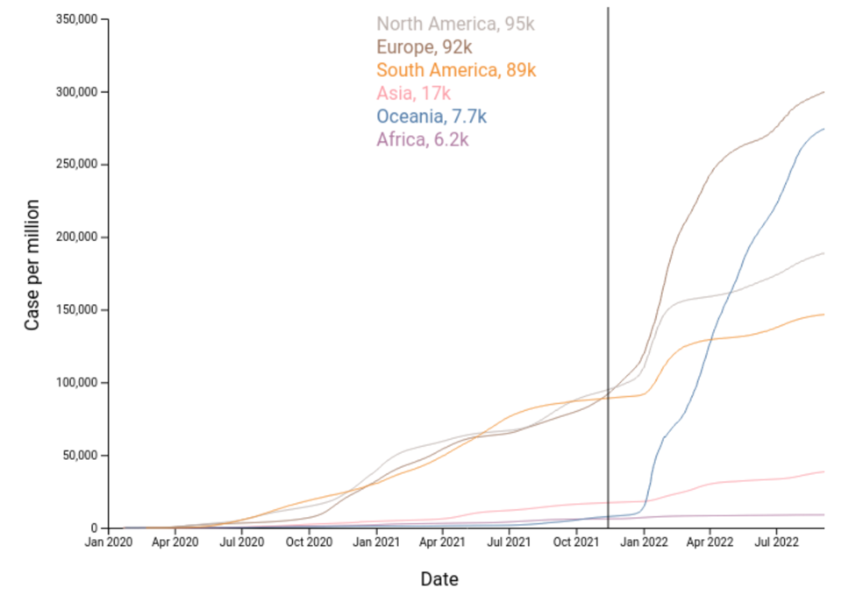Homework 4

Another inspiration was the interactive vertical line in Homework that visualizes the actual number that is plotted on a line chart. We added this feature to our time series of cool season precipitation and the Great Salt Lake elevation to visualize information in a similar manner as in Homework 4.

1. The National Weather Service color scheme

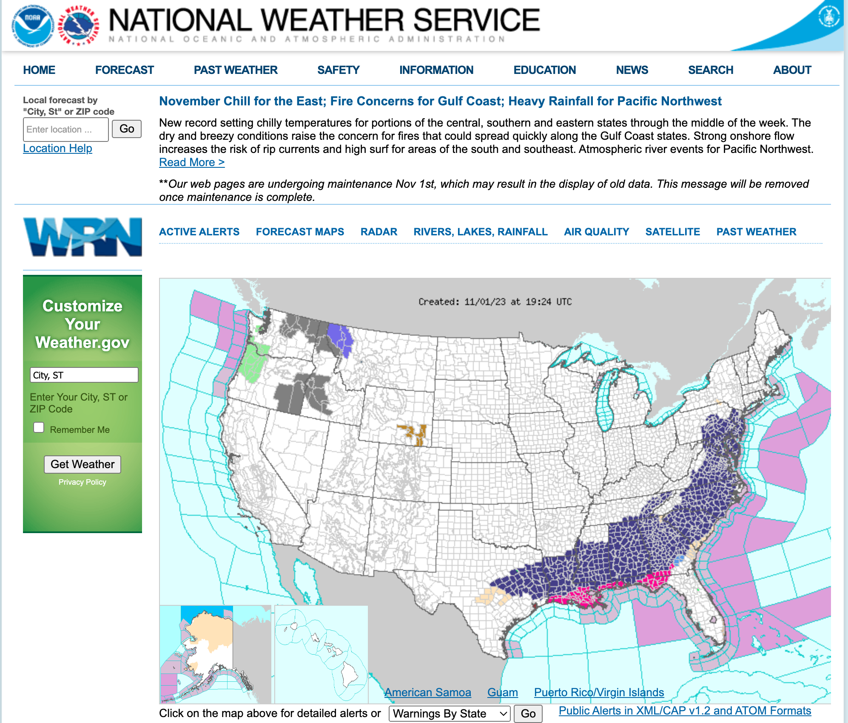

To be consistent with other webpages that visualize meteorological data, we decided to use a similar color scheme as the National Weather Service webpage shown above. This provides familiarity to users which allows for easier navigation and could enhance their understanding of the visualizations.

**Questions:**

The overarching objecting of our project is to produce a visualization to communicate the climatology of precipitation and temperature for Northern Utah. The questions we will answer are:

* What is the climatological distribution of monthly average temperatures and precipitation at observation stations across Utah?
* Is there a climatological trend in precipitation and temperature at observation stations across Utah? Is there a decrease in precipitation and an increase in temperatures?
* What is the climatological gradient of precipitation and temperature with elevation by month? How does it vary by month?
* Are there relationships between precipitation and temperature trends with natural resources and the occurrence of natural hazards?

We hope to build a stronger understanding of the climatology of Utah using our visualizations. The benefit of the visualizations is to communicate with non-atmospheric scientists the trends in precipitation and temperature, how terrain may affect these trends, and the implications towards natural hazards and resources.

**Data:**

In the project proposal, the source for our precipitation and temperature data was listed as the National Weather Service. However, after downloading and taking an initial look at the data, we found that the data did not have a sufficiently long time series of precipitation and temperature and/or data was missing from many sites. As a result, we decided to download data from the Global Historical Climatology Network daily (GHCNd) observation network for stations only in Utah. The GHCNd data used in our project only includes total monthly precipitation and average monthly temperature, so we had to calculate the following statistics for each site:

* Total yearly precipitation
* Total cool-season precipitation
* Average yearly temperature
* Average warm-season temperature
* Number of monthly and yearly precipitation and temperature records

We also needed to calculate the total mean cool-season precipitation from the 12 sites located in the Great Salt Lake (GSL) drainage basin. This was necessary so that we could plot GSL water elevation and the drainage mean cool-season precipitation so note any relationships between the two variables.

Next, we parsed the data by finding stations that have at least 30 years of data to meet the climatology requirement. In the project proposal, we state that each observational station needed to have 30 years of observations to be used in the project. However, when parsing the data, it became clear that 30 years of observations at a sufficient number of stations was not possible. The new threshold created was as follows: a station must have at least 9 months of observations each year and 24 years of observations for each month to be sufficient. This gave us 26 observation stations across Utah out of the original 657 stations. Although this was only 4% of the original number of stations, the stations displayed a wide variety of elevations and latitudes, giving us a more complete climatological analysis of the state.

**Exploratory Data Analysis:**

As atmospheric science PhD students, we’ve generated previous visualizations of temperature and precipitation, so we didn’t use any additional visualizations to initially look at the data. We were able to discern any oddities in the data simply by looking at the data before we rendered the data to the website visualizations.

Draft 1: Initial Plots

Below shows the first draft of our web visualization. The map on the left shows the 26 observation stations with sufficient records (black dots). The color chosen for the map was based on the default values I use in my research. However, I feel that it does not compliment the color scheme. The radius of the dots double when the user hovers to aid in selecting a station due to their small size. Lastly, the radius size of the dots were chosen to prevent overlap between stations.

By selecting one of the dots, the figures to the right change based on the selected station. Since precipitation ranges only with positive values and is measured based on depth, a bar chart was chosen because it can convey that same range in possible values. Temperature is chosen to be represented with a line plot with circle markers since the values are continuously throughout the year, but markers were added to allow for user interaction.

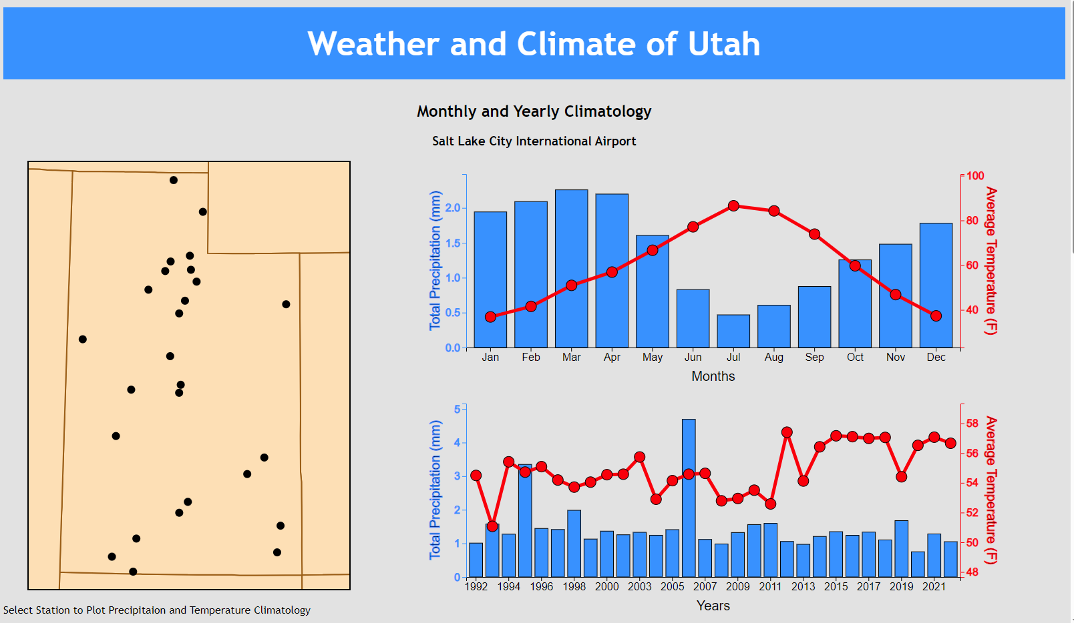

The general color scheme was chosen to have the same feel as the National Weather Service page, linked [here](https://www.wpc.ncep.noaa.gov/index.shtml#page=ovw). This page uses a lot of light blues, shades of gray, and the logo has the same bright red color. Additionally, the red and blue colors were chosen to have high luminance contrast to the light background. However, we feel that our visualization has an outdated look and the brown shades of the map does not look appealing with the gray background. Therefore, we will try a dark color scheme next.

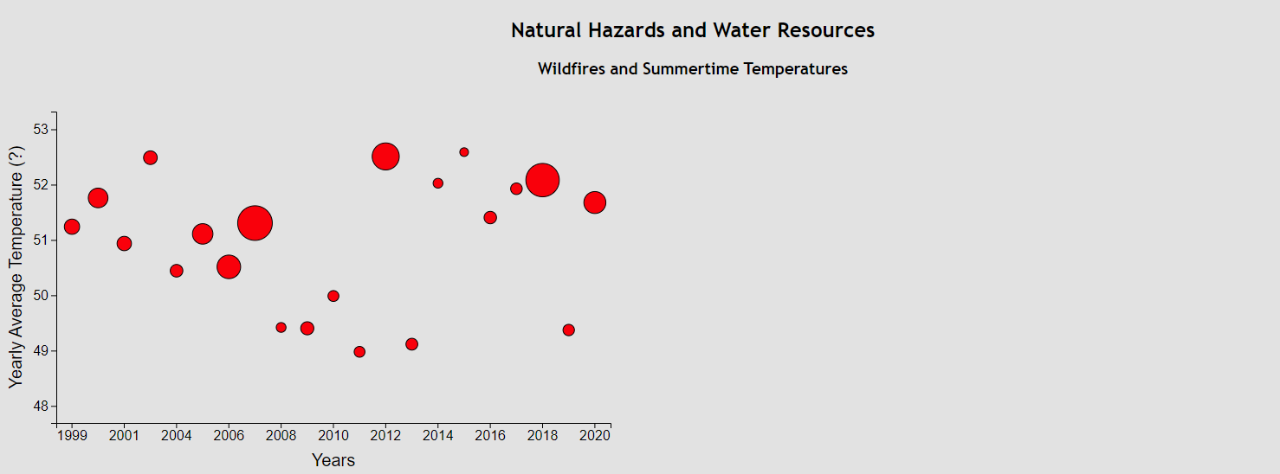 The next figure started was the scatter plot of average summertime temperatures per year with the marker scaling in size with the acres of wildfires that year. Here, the figure does not center on the page, which needs to be changed. There needs to be an interactive way for the user to determine the acres and a legend should be added. The size of the markers was linearly scaled with the max size chosen to prevent overlap between markers.

The same color as the line plots of the first visualization was chosen for consistency in temperature plots.

Draft 2: Dark Color Scheme

The banner was changed to an image of a snowy mountain range in Utah for the purpose of attracting a user. The image also offers a color scheme for the visualizations.

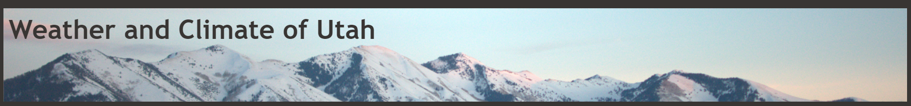

Below is the updated monthly and yearly climatology at the selected stations. The webpage is updated to automatically load the Salt Lake City international airport station, making the figures on the right populate at startup. The shade of purple from the map was taken from the banner image above. However, it lacks a strong contrast between it, the background, and the station dots, therefore, a lighter shade should be chosen.

The font style of the plots was made consistent with the webpage’s styles. And many of the font sizes were increased to aid in readability.

Additional to the doubling of the station markers during hovering, the station name is now listed above the marker. Hover, some station’s names are too long and run past the figure, this needs to be fixed later on.

Hovering events were added to all the bar chart rectangles and marker circles of the precipitation and temperature plots. During hovering, the color shade changes to one of a lighter saturation, creating high contrast with the background. The display of numerical values should be added in the future.

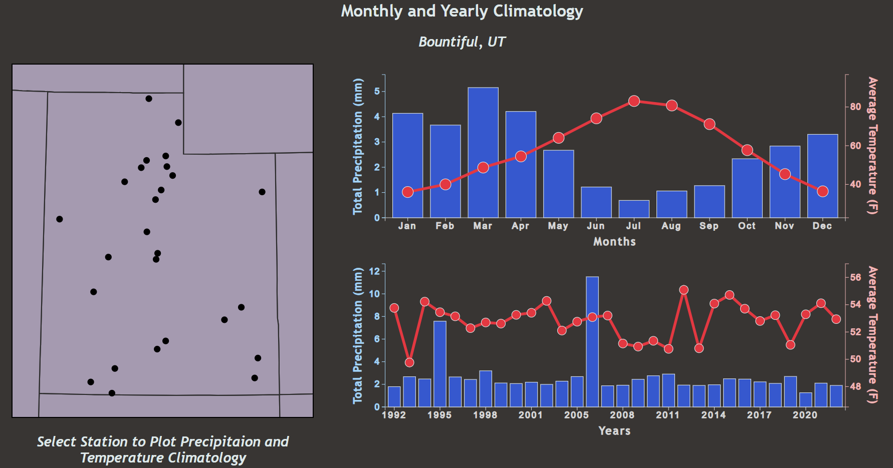

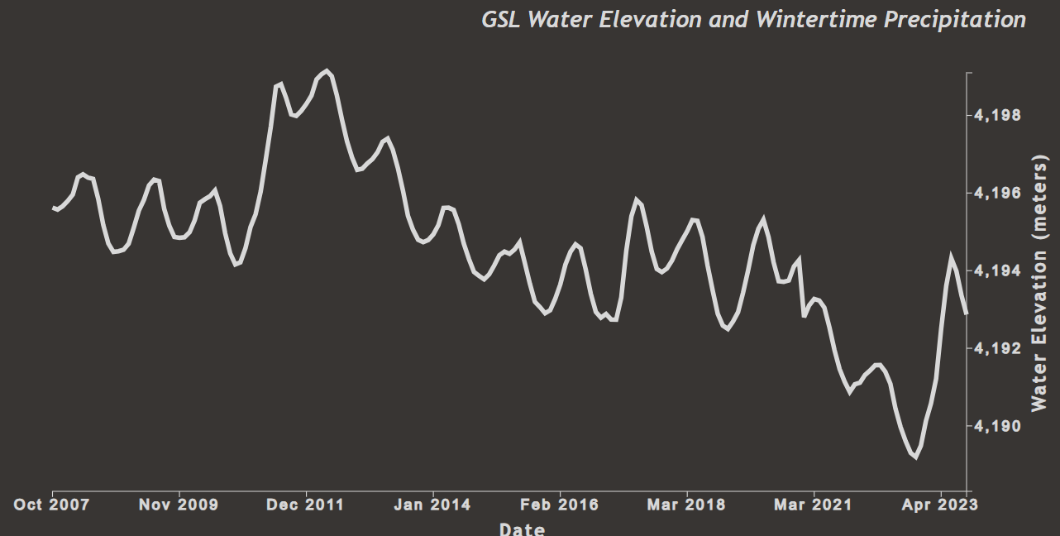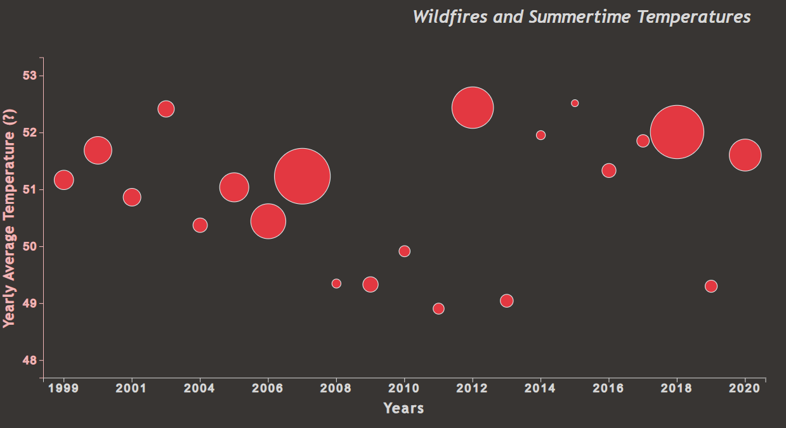Above is the Utah wildfire acres and the summertime temperatures. The only addition between drafts is that during hovering the total wildfire acres burned each year is listed above the marker.

Above is the added figure of the Great Salt Lake water elevation versus wintertime precipitation. Currently only GSL water elevation is added. The right y-axis was chosen because the precipitation axis will be added on the left for consistency with the wildland fire plot having temperature on the left y-axis. The interactivity that we want to add is a sliding vertical line to display the water elevation.

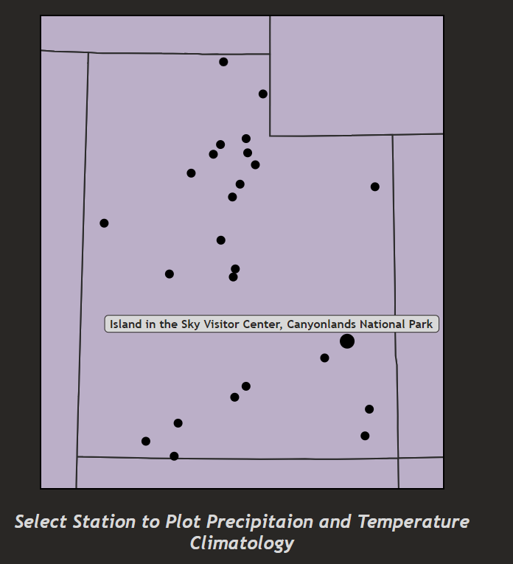Draft 3: Interactivity

To the left shows the updated map of Utah. The background map color was lightened to increase contrast between the station dots and the webpage background. Additionally, it shows the interactivity of the plot, how when a user hovers over a station, the circle doubles in size and the location of the observation station is labeled.

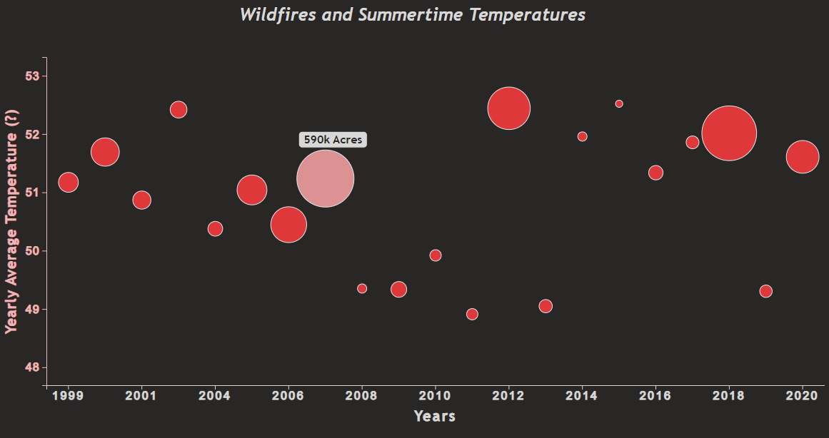 Below, is the updated version of the wildfire and summertime temperatures. While hovering, the total acres burned in Utah for that year shows in a label and the saturation of that circle’s color decreases. Might want to decrease the saturation so that the area is easier to estimate between circles and have the hover color darken. Lastly, the figure is now centered on the page.

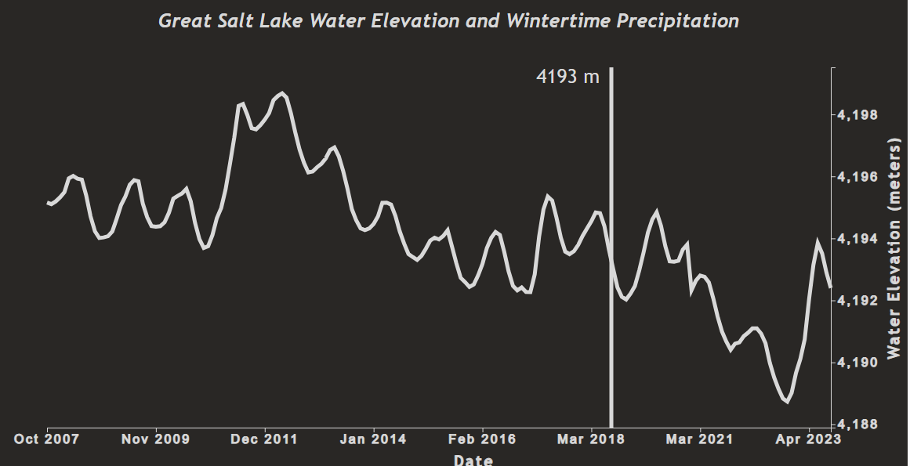 Below, the Great Salt Lake water elevation and wintertime precipitation figure was updated to have a vertical line with label indicating the water elevation at the corresponding date. Lastly, the figure is now centered on the page.

**Design Evolution:** What are the different visualizations you considered? Justify the design decisions you made using the perceptual and design principles you learned in the course. Did you deviate from your proposal?

We considered a couple of visualizations shown in the prototypes below:

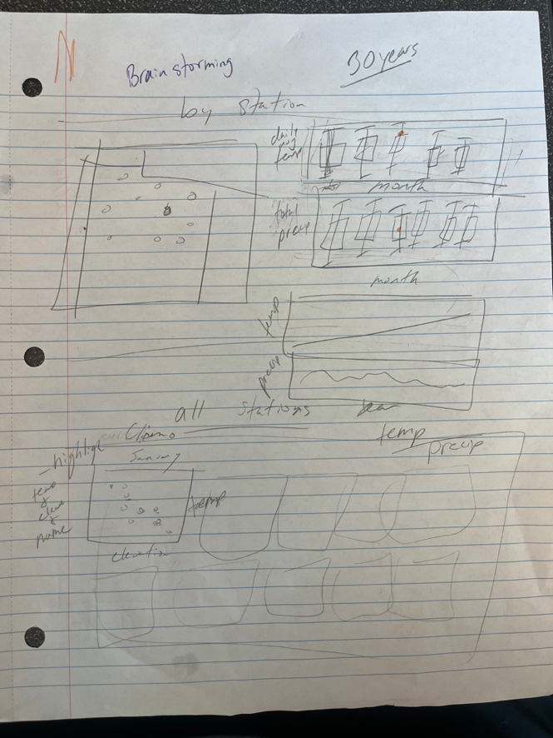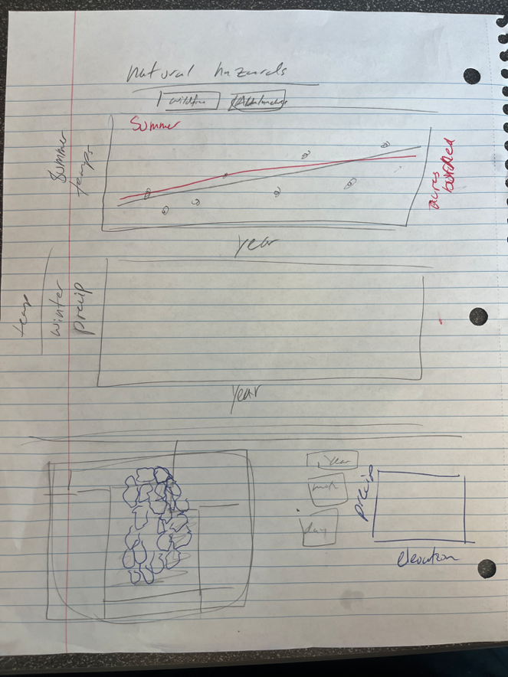Prototype #1 (brainstorming)

Prototype #2a (first section of webpage)



Prototype #2b (second section of webpage)



Prototype #2c (third section of webpage)



Prototype #3a (first section of webpage)



Prototype #3b (second section of webpage)



Prototype #3c (third section of webpage)



Prototype #4a (first section of webpage)



Prototype #4b (second section of webpage)



Prototype #4c (third section of webpage)

